

Science
Biology
Year 7

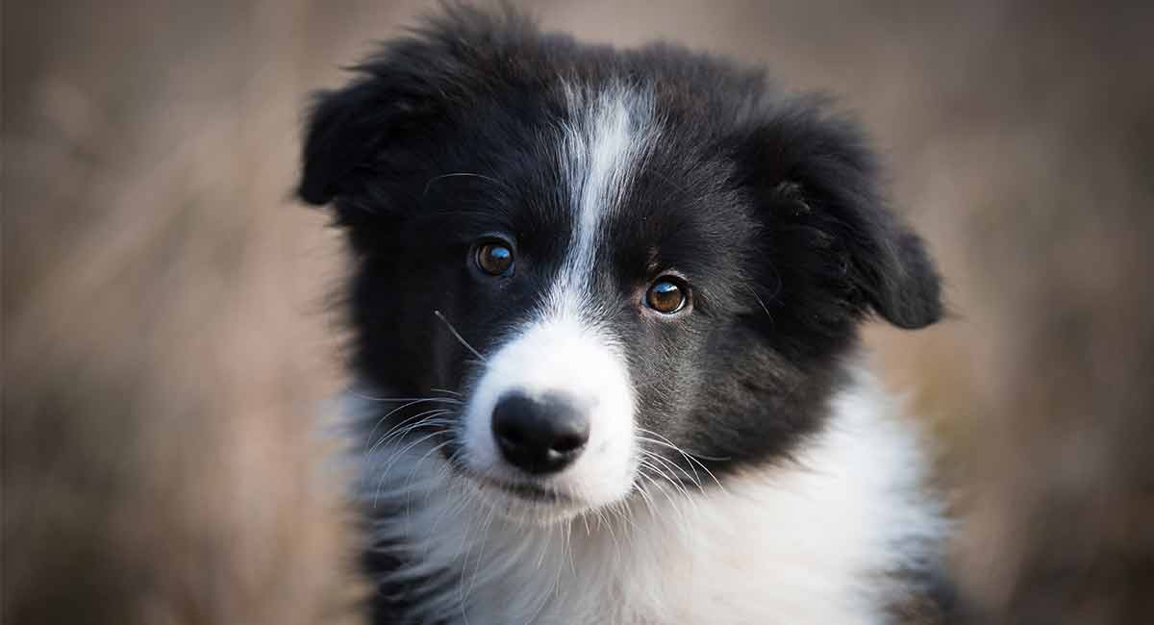
TASK 1 – Using a dictionary
Find the definition of these words using a dictionary
Word | Definition
Organism
Dead
Classify
Taxonomist
Vertebrate
Invertebrate
Similar
Different
Botantist

Task 2- Vocab
Link the word to the meaning
Organism |  | Something that has no living characteristics
Dead |  | Organism with a backbone
Non-Living |  | Characteristics which are the same
Taxonomist |  | Group things by their similarities and differences
Vertebrate |  | A scientist that studies plants
Invertebrate |  | A living thing
Similarities |  | Characteristics that are not the same
Differences |  | Organism without a backbone
Classify |  | Something that was once alive
Botanist |  | Scientist who classifies living things into groups

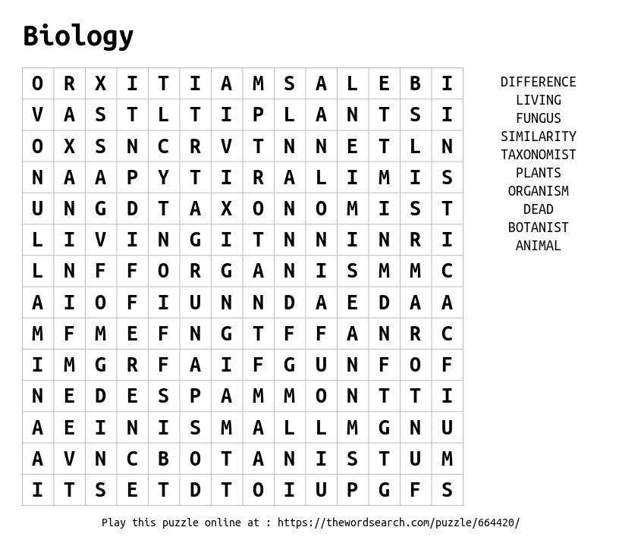
Task 3- Word Search

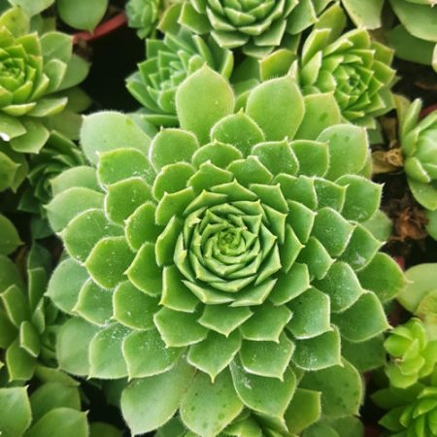
Task 4- Look, Cover, Write and Check
Repeat each word 3 times
Look, Cover | Write | Check
Biology

Classification

Similarities

Differences

Organism

Animal

Look, Cover | Write | Check
Plant

Fungus

Taxonomy

Botany

Vertebrate

Invertebrate

Task 5- Mindful Activity
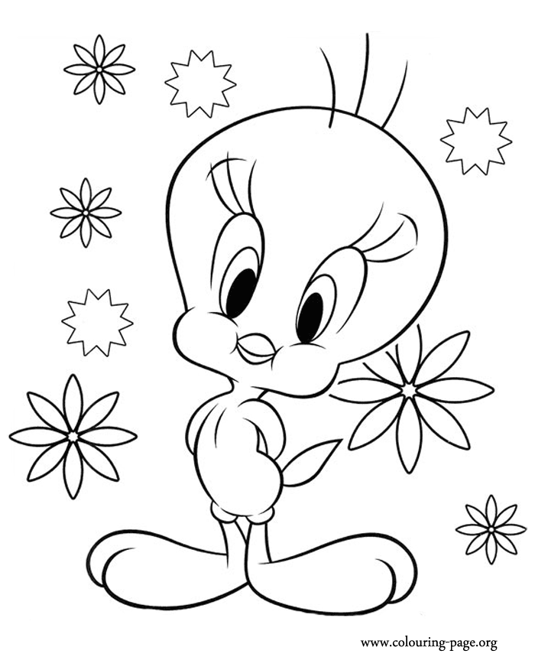
CHECKLIST

Completion Tally
 | Student shade when completed | Teacher signature
Task 1

Task 2

Task 3

Task 4

Task 5

